**Researching yourself**

**Self-awareness, a detailed plan and a knowledge of how to market yourself and your skills can put you ahead of the competition. Apart from technical skills and specific qualifications, transferrable skills (soft skills) are a set of abilities that go beyond a particular job or organisation.**

*1. Below you will find a set of high profile transferable skills for the tech industry. Match the personal characteristics to the self-reflection questions (a-h).*

1. self-awareness

2. resilience

3. strategist

4. cultural-fit

5. analytical thinking

6. continuous-learner mindset

7. work-ethic

8. ingenuity

a. Do you seek to accommodate regular task changes, adjustments, and respond well to negative challenges? -2

b. Do you look for a pattern of learning, either from peers on the job, open-source contributions, structured training or through tech community involvement? - 6

c. Are you dedicated to professionalism, do you value a healthy work environment by prioritizing tasks by impact or by practicing time-management to complete quality, on-time work? -7



d. Do you have the ability to set boundaries and adapt to the others, do you find ways to monitor your reactions and your motivation? -agree

e. Do you enjoy planning, can you identify long-term goals and potential ways to reimagine what is possible with technology? -3

f. Do you try to find a way for asking the right questions, solving problems with creative solutions, and driving innovation? -8

g. Do you embrace the core values of the company that you would like to work for? -I think this is 4

h. Can you easily spot trends, outliers, performance indicators, and critical events? -5

*2. Draw a mind map showing your strengths and weakness. Try to use the following phrases:*



x | o |x

-----------

| |

-----------

x | |O

😊)))))))))) :(ok

Ez ggwp

*3. In pairs, take turns to ask and answer the questions about the “top cross-cutting skills for the future” detailed in Fig 1.*

*In a 1-1 Q & A session, discuss your individual strengths and weaknesses with a partner, giving specific evidence of professional behaviour.*

*Ex. Most employers say that one characteristic they are looking for in top-tier employees are analytical skills. How do you expect to apply analytical thinking in your work?*

*I am excellent at interpreting data to see cause and effect and I am able to use this information to make effective decisions.*

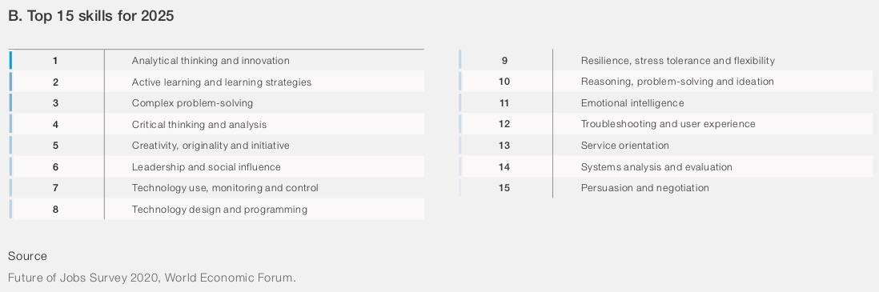

**Writing up a resume or a CV**

* What do you think are the key qualities of a CV?
* What type of information should a CV contain?
* How would you organise the information in your CV?

*Imagine you only had 20 seconds to look at the following* [*CV*](https://www.monster.com/career-advice/article/sample-resume-computer-programmer-entry-level) *. What would you look at? What would your impression of the applicant be?*

Listening practice

*1. The following conversation focuses on ways of structuring a CV. Listen and complete the CV structures:*

___________CV

1. ________ large letters

2. ________details

3. (_____ _____)

4. __________/academic qualifications

5. _____ ______

6. _______ and _______

7. ______________

8. ____________

___________ CV

9. ________ _________

10. _______ _________

11. _______ ______/ Career profile

12. ____________

13._______ ________ details

14. ________/professional qualifications

15 ____________

16. ____________

*2. The following video showcases Clement Michailescu, a software engineer, discussing some aspects of the CV that helped him get an entry level position at Google.*

**Step 1. Watch the video and take notes on** :

* how information is organised
* what are the positive aspects and
* what are the negative aspects of the CV

Step 2. Based on your notes, formulate 4 useful requirements (what is required/what is not required) that could apply to successful CV writing.

*Ex. You should use bullet points and not full sentences to make information stand out.*

*You mustn’t advertise any skills that you cannot support with evidence.*

**Creating a strong first impression**

Writing a personal statement

***A personal statement (Resume summary)*** *is a brief statement of the type of person you are, your skills and your achievements. It always comes near the top part of the CV, before the main body and presents the facts in the most positive way. A well-written personal statement will immediately capture the attention of the employer and make them want to find out more about you.*

*1. Read the following personal statements (A-C) from a skills-based CV and find words and phrases which demonstrate the following points. Make comments where necessary and remember that not some examples may not fully comply with the listed criteria.*

1 education

2 experience

3 knowledge

4 character

5 success

A.

|  |
| --- |
| IT professional with over 5 years of experience specialising in IT department management for international logistics companies. Can implement effective IT strategies at local and global levels. My greatest strength is business awareness which enebles me to permanently streamline infrastructure and applications. |

B.

|  |
| --- |
| Self-starting and civic-minded data scientist with two years of experience using datas to inform and drive sustainable solutions. Highly skilled in datas visualization, data mining, statistical analysis, and communicating complex data sets to diverse audiences. |

C.

|  |
| --- |
| Honours student of Exter University’s BS in IT program, with significant academic credentials reinforced by programming experience gained during internship with ABC Company. Good programming abilities, grasp of multiple technologies and attention to detail. Strong knowledge of object-oriented programming and application development tools using Microsoft VB.Net, C#, .Net, C++, ASP.Net; Python and VBA. Known as a self-starter, team player and multitasker-strive to consistently exceed expectations. |

*2. Write an impressive personal statement for your own CV including the criteria listed in the previous exercise.*